EXPERIMENT-5
AIM:
To analyze and display the color histogram of an input image using OpenCV and Matplotlib in Python.
Program:
import cv2
import matplotlib.pyplot as plt
def analyze_histogram(image_path):
image = cv2.imread(image_path)
if image is None:
print("Error: Image not found!")
return
cv2.imshow("Original Image", image)
color_channels = ('b', 'g', 'r')
plt.figure(figsize=(10, 5))
for i, color in enumerate(color_channels):
histogram = cv2.calcHist([image], [i], None, [256], [0, 256])
plt.plot(histogram, color=color, label=f"{color.upper()} Channel")
plt.title("Color Histogram Analysis")
plt.xlabel("Pixel Intensity")
plt.ylabel("Frequency")
plt.xlim([0, 256])
plt.legend()
plt.show()
cv2.waitKey(0)
cv2.destroyAllWindows()
analyze_histogram(r"C:\Users\sivad\OneDrive\Desktop\Computer Vision\sample(1).jpg.png")

Input:
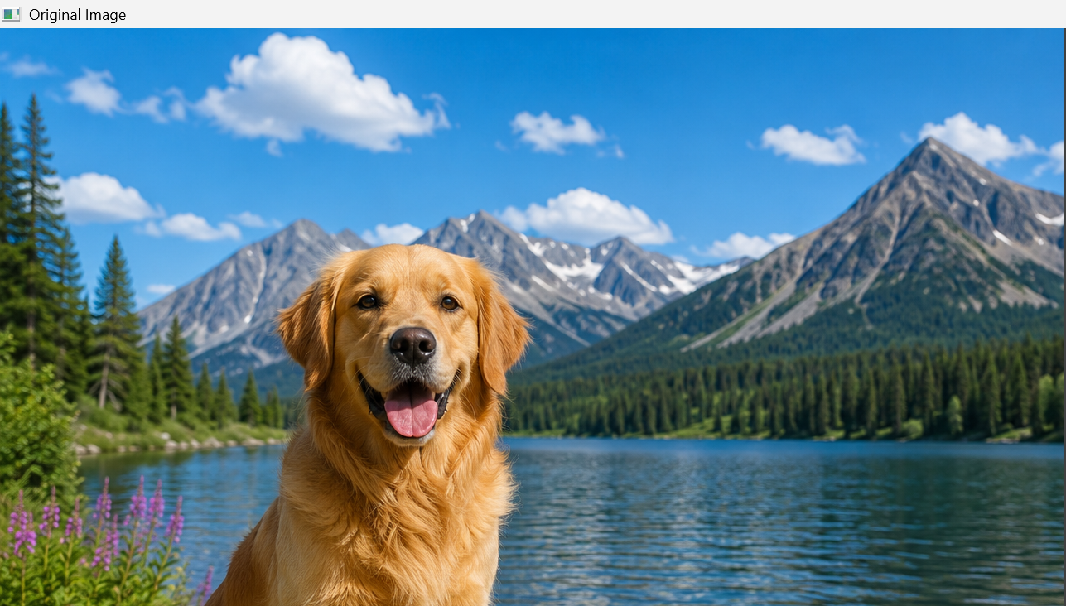
Output:
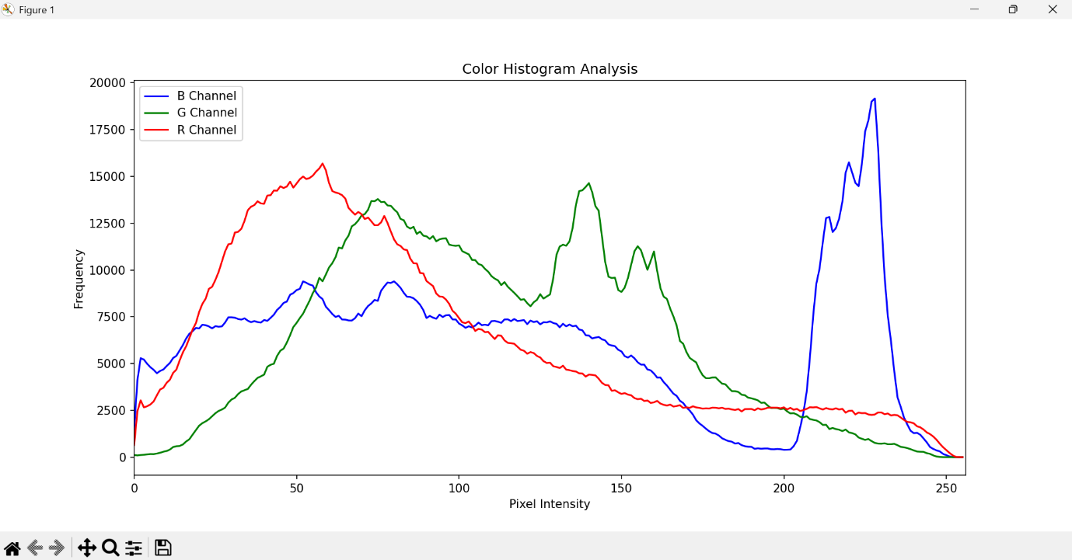
Result:
Successfully analyzed and displayed the color histogram of the input image based on its color levels using OpenCV and Matplotlib in Python.

